Newsletter № 1

  - HEALTHY EATING AND MOVEMENT FOR A BETTER QUALITY OF LIFE

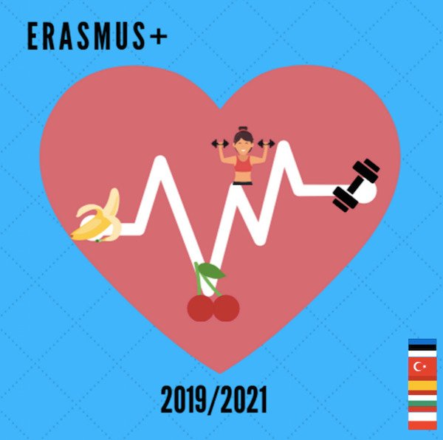

The first exchange is a joint training event to be held in Turkey.
November 2019

As a result of these actions, we will obtain the following results:
As a result of these activities, we will obtain the following outcomes and outputs:
- teachers will gain an insight into the current situation in the partner countries in terms of physical exercise, eating habits, obesity and eating disorders.
- participants will develop a better understanding of the psychological factors of eating disorders which lead to obesity
- the teams will establish a common methodology for the selection of students and create plans for the upcoming exchanges
- workshop and seminar materials and activities designed by specialists
- topic-related studies prepared by partners
- comparative analysis of the results of the survey applied on students before C1
- comparative analysis of obesity rates in each school/country
- methods to involve parents in supporting nutritional education
- evaluation report and newsletter 1
- materials for the two final brochures
- evaluation forms
- certificates of attendance,
- photos
The activities combine visits to PE classes, school cafeteria, school premises and topic-related workshops, seminars etc. They are organized during the regular working hours, with the exception of cultural activities and events which take place after classes and are meant to strengthen the intercultural, interactional and personal component of projects. Participants are expected to bond and create long-lasting relations for an optimal implementation of the projects.

SCHOOL MEETING
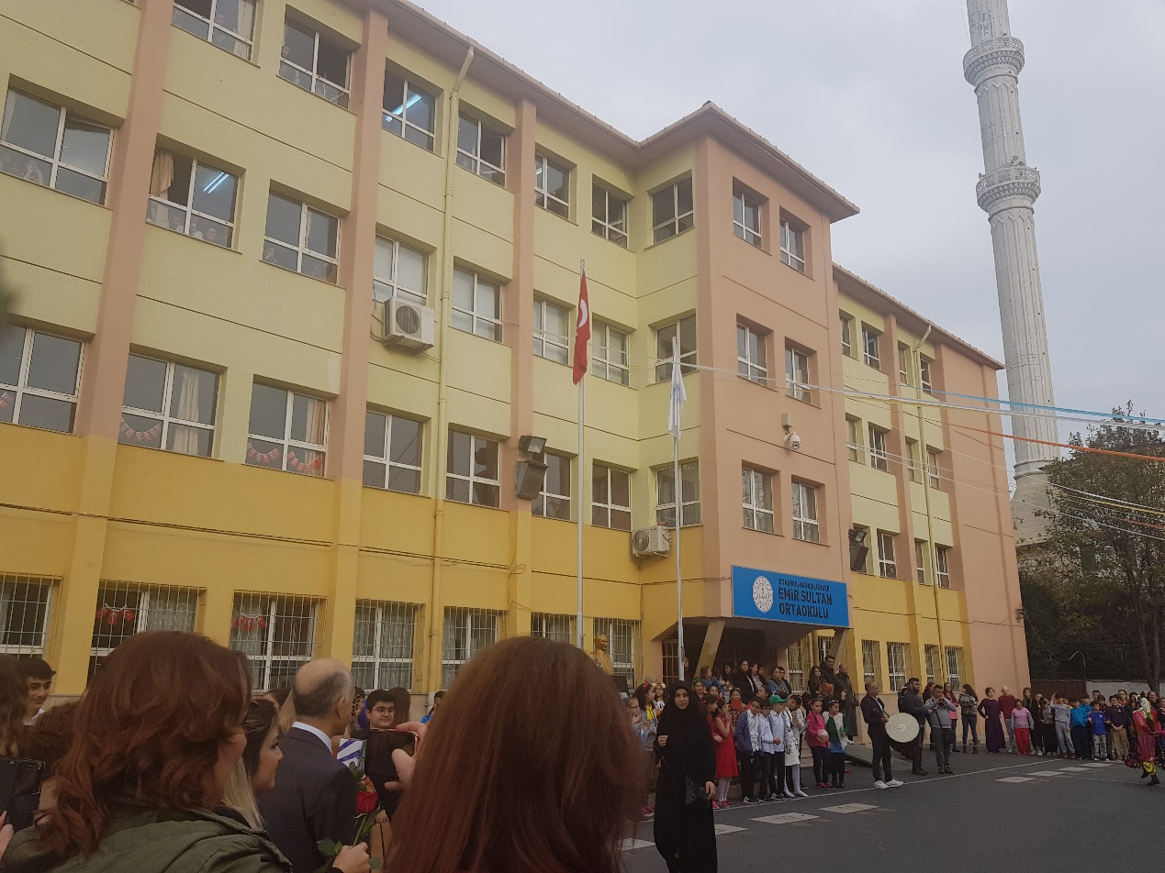

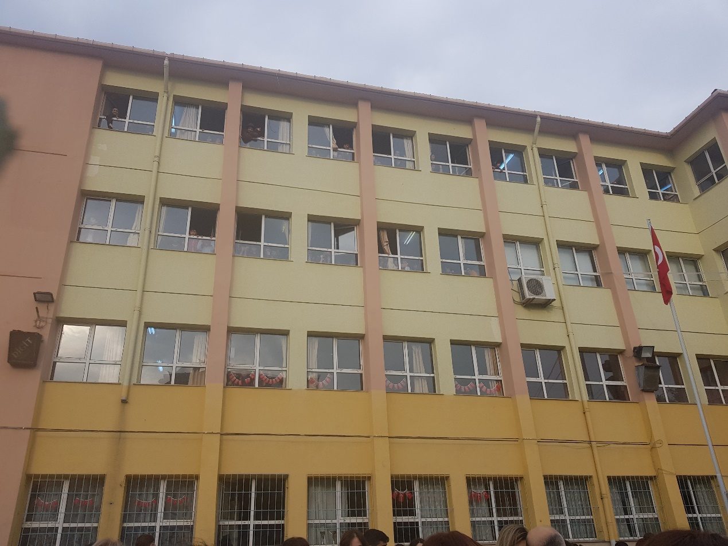

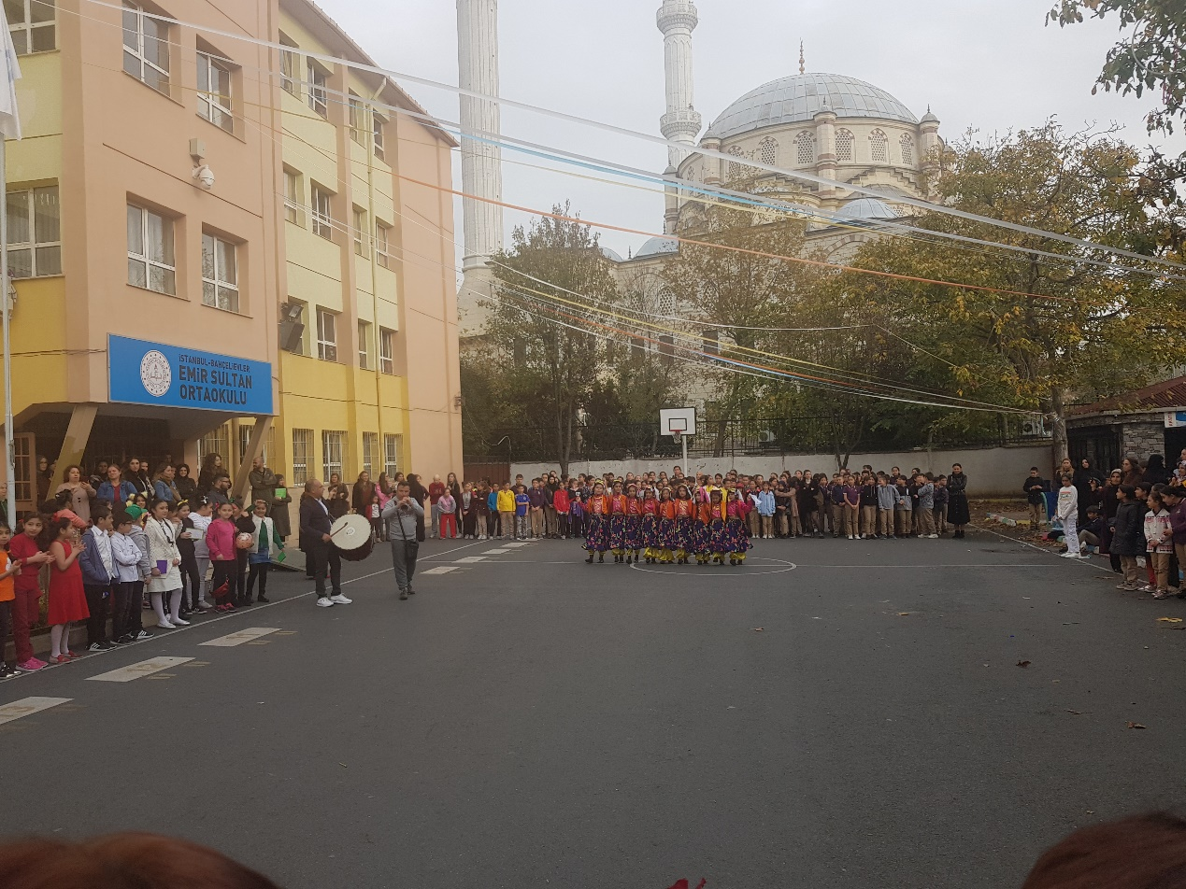
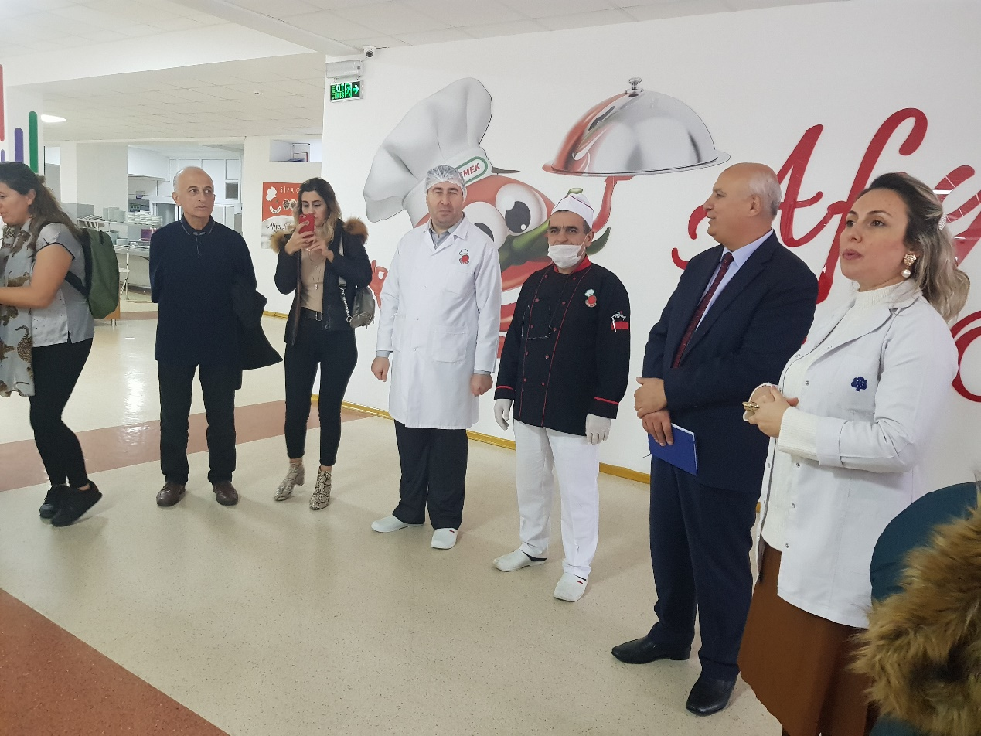

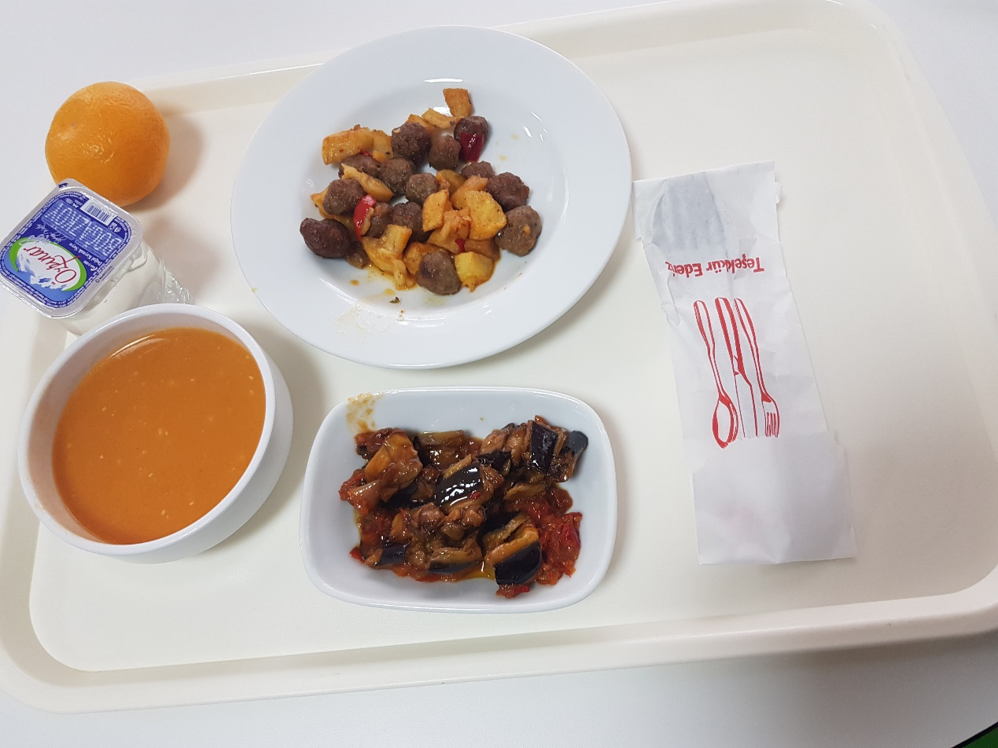
https://twinspace.etwinning.net/93787

https://sites.google.com/view/healthy-eating-and-movement-fo/about-proejct?authuser=0

New projects 2019\Erasmus Healthy eating\C1\Bulgaria\nutritional trends.ppt

New projects 2019\Erasmus Healthy eating\C1\Bulgaria\overweight children.ppt

New projects 2019\Erasmus Healthy eating\C1\Bulgaria\questionnaire HEALTHY EATING.docx

New projects 2019\Erasmus Healthy eating\C1\Estonia\Childhood obesity Erasmus+ Healthy eating.pptx

New projects 2019\Erasmus Healthy eating\C1\Estonia\Nutrition tips С1 for students.pptx

New projects 2019\Erasmus Healthy eating\C1\Estonia\Questionnaire for students.pdf

New projects 2019\Erasmus Healthy eating\C1\Poland\Ankieta o odżywianiu turecka po angielsku.docx

New projects 2019\Erasmus Healthy eating\C1\Poland\Prezentacja - The situation of overweight children in Poland.pdf

New projects 2019\Erasmus Healthy eating\C1\Poland\prezentacja o szkole Turcja.ppt
New projects 2019\Erasmus Healthy eating\C1\Spain\Nutritional trends.pdf

New projects 2019\Erasmus Healthy eating\C1\Spain\School presentation (Pili).pdf

New projects 2019\Erasmus Healthy eating\C1\Spain\Survey results- 23th- 30th november (Ester).pdf

New projects 2019\Erasmus Healthy eating\C1\Turkey\Turkish Cuisine.pptx

New projects 2019\Erasmus Healthy eating\C1\Turkey\Turkish Educational System .pptx

